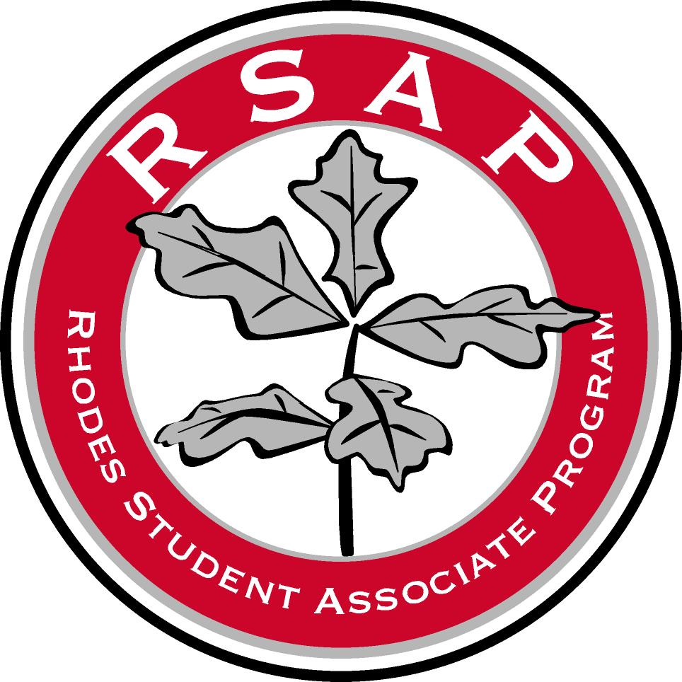

Rhodes Student Associate Program

2015-2016 Student Associate Handbook

RSAP Student Handbook Contents
Letter from the President…………...………………………………...2
Introduction………………………………………………………....3
Mission Statement, Background, and Purpose………………………...4-5
The RSAP Committee and Contact Information..………………………..6
My Experience with RSAP: Student Associate Quotes…………………...7

Getting Started
Answers to Frequently Asked Financial Aid Questions…………8-10
Expectations: Yours and Theirs……………………………...11-12
Tips for Meeting with your Supervisor……………..……………13
How NOT to Succeed on the Job………………………………..14
Basic Work Tenets…………………………………………....15
Setting Goals…………………………………………………16
Problematic Situations and Solutions………………………...17-19

Everything You Ever Wanted to Know About:
Moodle Journals………………………………………………20
Evaluations…………………………………………………..21
Seminars……………………………………………………..22
All’s Well That Ends Well………………………………………....23-24
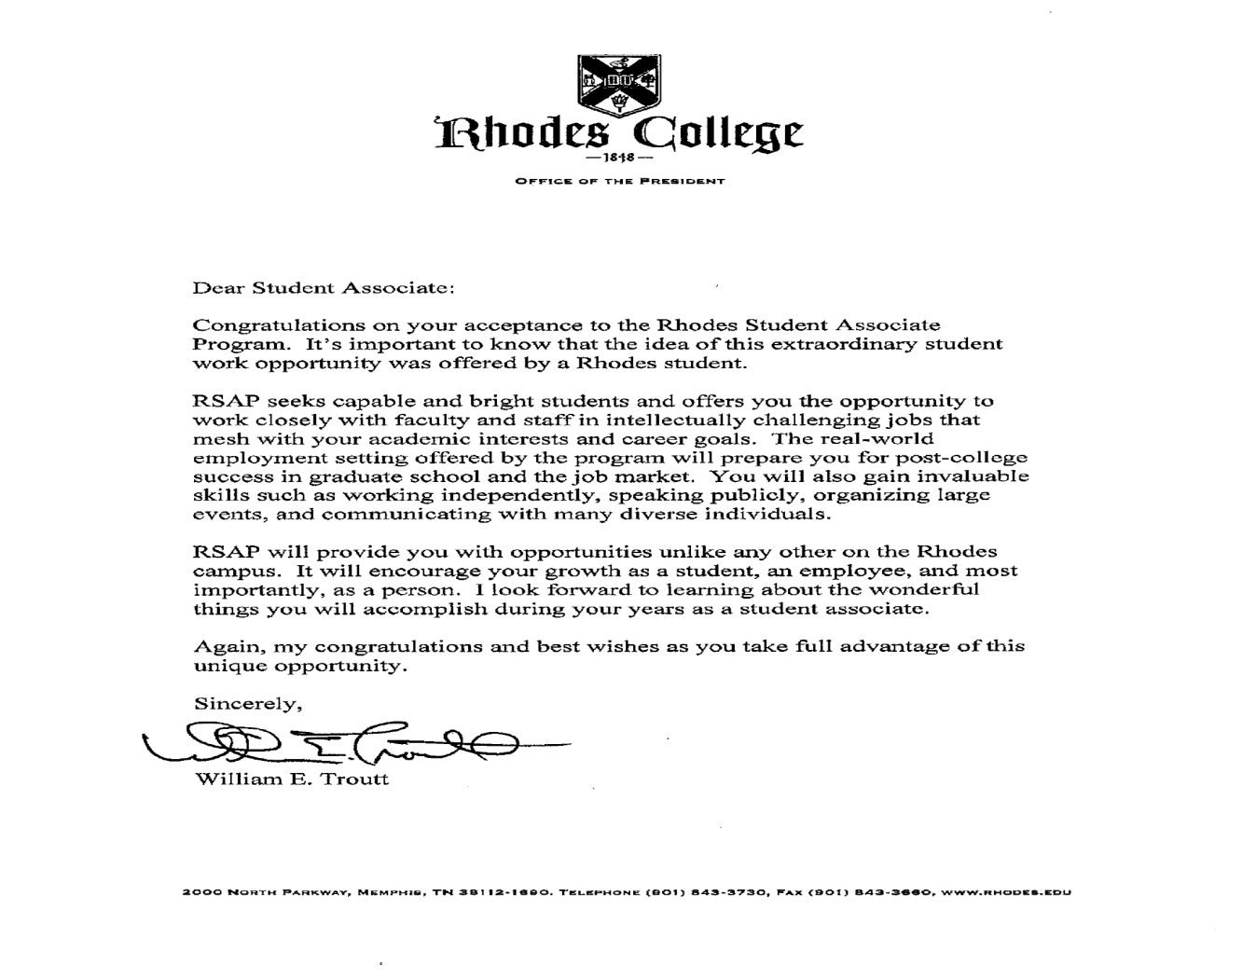
Introduction
Welcome to the Rhodes Student Associate Program! The RSAP program was developed in 2004 with the goal of giving students real-life work experience and professional responsibilities that are not traditionally associated with on-campus employment. Since its inception, the Program has grown to include over 100 positions, in more than 40 academic and administrative departments. These students represent the best Rhodes has to offer.
This handbook has been compiled for your use by the RSAP coordinators in the Financial Aid office. In its pages, you will find information concerning the policies and procedures for RSAP. The handbook also serves as a guide to working as an RSA in your department, with tips and expectations required from the RSAP program and your individual supervisor.
You will additionally find a list of your duties as an RSA and the general outline of the program. In the back of the handbook, we have included a forms section, which has all the necessary forms that you or your supervisor might need throughout the year. Please keep this guide as a reference for your use throughout the entire year.
Thank you for your commitment to this program and the students of Rhodes. We hope that you find the RSAP Student Handbook helpful, and we are always here to answer any other questions that arise.

Mission Statement
Our vision is to bring highly motivated, highly qualified students that are specifically chosen by Rhodes faculty and staff to facilitate and influence the student work experience to provide valuable and meaningful service to Rhodes.
Background
In 2002-2003, students and administration began to explore the possibility of reshaping student employment at Rhodes. Grants for this purpose from Lumina and Mellon foundations were approved and funded. Throughout 2003-2004, a committee studied existing student employment options and sought ways to add depth and breadth to the program. The committee has reviewed similar programs at other institutions. Finding no model that speaks to the specific goals for this program, the committee developed working policies and procedures to support a pilot project for a new initiative: The Rhodes Student Associate Program (RSAP).
RSAP launched in the fall of 2004 with 20 student associates in 18 different departments. The program quickly gained popularity and prestige, resulting in the expansion and increasingly competitive student and position selection processes. In 2011-2012, there were 101 student associates in 44 academic and administrative departments. One program goal is to expand the number of positions funded while maintaining high quality of positions for students, supervisors, and Rhodes.

Purpose
RSAP provides enhanced employment opportunities for a select group of highly qualified, highly motivated Rhodes students, who collaborate with specially chosen faculty/administrator supervisors to provide valuable, meaningful service to both the student and the college. The Student Associate has a rare opportunity to move from theory to practice, while honing job skills, exploring career options, developing professional networks, and earning substantial wages to offset the cost of attendance.
RSAP seeks to add dimension to student employment opportunities for Rhodes students, offering depth and breadth of the earn-as-you-learn experience. RSAP aims beyond traditional work study and assistantship-type jobs. It is expected that Student Associates will have little-to-no time on the job for study.

The RSAP Committee
Michael Morgan | Director of Financial Aid
Stacey Duncan | Assistant Director of Financial Aid
Bob Johnson | Vice President of Information Services
Wanda Jones | Director of Accounting
Sandi George Tracy | Director of Career Services
Hailey Woods | RSAP/SE@R Information Coordinator (Financial Aid RSA)
Olivia Butler | RSAP Coordinator (Financial Aid RSA)

Communication with Financial Aid
The RSAP Coordinators (FinAid RSAs) are your primary contact for answers to questions, information, or for assistance with any program issue. The Coordinators will notify all student associates of program activities and Moodle journals, and will communicate important information.

Contact Us
Olivia Butler & Hailey Woods
RSAP Coordinators
finaid@rhodes.edu
901-843-3712

My Experience with RSAP: Student Associate Quotes

Individual RSAs respond to questions via periodic Moodle journals. Here are some notable responses that typify an RSA’s experience in the program:

Sallie Handley ’14, Health Services Advising

My time with the Rhodes Student Associate Program has granted me so much more than a paycheck every other week. I have learned valuable, hands-on work skills and formed amazing connections and relationships among faculty and staff. I am gaining real work experience in a professional setting. I have learned so much from the RSA Program, and I am so excited to return to my position next year.

Andrew Grissom ’12, Archaeology Lab Manager

My two years as an RSA have given me valuable experience in archaeology-related projects. As a two-time team member of the Rhodes Archaeology Maymester Field School, I gained the opportunity to work and interact with artifacts uncovered in the field on a yearlong basis. Also, this year, my supervisor enlisted me in a genealogical project, in which our team digitizes and records entries from ledgers that previously belonged to a local funeral home. My position ultimately enhanced my experience in the discipline of archaeology, and allowed me to gain valuable connections with professionals in cultural resource management.
Kelly Parry ’12, Kinney/Bonner
I cannot imagine what my four years at Rhodes would have been like without participating in the RSA Program. With my RSA position, I was able to strengthen my understanding of our campus community and develop organizational and interpersonal skills. I am also grateful to the program for the opportunities my position provided to get to know more students, faculty, and administrators and build relationships that will continue long after graduation. My supervisors and I have shared many memories together that I wouldn't trade for anything. I am proud to say that I have been able to work as a Student Associate in the Bonner Office.

Jasmine Gilstrap ’13, Big Diehl Associate
My first year as the Big Diehl RSA has been a whirlwind of a year that I would not have been able to get through without the help of the entire Big Diehl committee. The tickets to Memphis Grizzlies games are always the biggest draw for students in terms of Big Diehl events. The NBA lockout disrupted some of our scheduled events, but as a team, we were able to find alternatives. In addition to working with the team to plan the end of the fall and the entire spring schedules, another highlight from my first year RSA experience was planning the Ski Trip and Nashville Trip, both of which involved lots of planning, but were very successful events in the end.

Getting Started
Answers to Frequently Asked Financial Aid Questions.
1. What do I need to do to get my award in Financial Aid?
Your supervisor will submit your Request to Hire form to Financial Aid, and you will need to sign this document agreeing to the terms of your agreement. You may not begin working until this form has been completed and verified. The Coordinators will inform you when you may start your new position.
2. What other forms do I need to submit?
If you have not worked on campus before, you will need to submit your I-9 and W-4 documents as well as supporting documents to the Financial Aid office BEFORE you begin to work.
3. When can I start?
The earliest date you may begin is the first day of classes for the each semester. This is assuming all your paperwork has been approved and you have been authorized to work (see 1 and 2).
For the 2015-2016 school year, the earliest day you may begin work in the fall and spring semesters is August 26, 2015, and January 13, 2016, respectively.
4. When is my last day?
Generally, your last day of work for the year is the last day of exams in the each semester.
For the 2015-2016 school year, the last day you may work in the fall and spring semesters is December 16, 2015, and May 7, 2016, respectively.
5. Can I work during breaks and holidays?
You may work during any breaks during the fall and spring semesters if you choose to do so. However, you may not work during winter or summer break.
6. Do I have to clock in and out?
YES, you will be using a time-keeping system called AsureForce. You must clock in and out each day using a computer in your department.
7. Does the RSAP money I earn count towards my financial aid for the year?
YES, your RSAP estimated award that you see on BannerWeb counts towards your total Cost of Attendance even though you will not receive this money as part of your awards at the beginning of each term. Compensation for work in this program is paid directly to you every two weeks based on the actual number of hours worked. Unless you apply these earnings toward your student account, these earnings will not reduce the balance owed to the college.
8. How many hours may I work each week?
RSAs must work between 10-15 hours per week. The average student works between 12 and 15 hours per week. You and your supervisor are responsible for arranging a suitable work schedule.
9. Is there a GPA requirement for RSAP?
Yes. The minimum GPA required for RSAP is 2.75.
10. When will I get paid?
You will get paid on a bi-weekly basis on the same schedule as all college employees.
11. Can I get my paycheck direct deposited?
YES! Direct deposit is an effortless way to ensure that your check is deposited straight to your designated account on pay-day. To sign up for direct deposit, print and submit a direct deposit form to Rhodes Express. Forms are available on InRhodes under Rhodes Express > Download Forms.
12. Can I have another job on campus in addition to my RSAP position?
You may not hold another job on campus in addition to RSAP, due to the responsibility and time that RSAP requires. If another position on campus remains vacant and the needs of the college or department justify your holding this position, the RSAP committee will consider your proposal for working both jobs. Decisions regarding exceptions to the rule are made on a case-by-case basis.

Expectations: Yours and Theirs
When you begin work as a Student Associate, you will, undoubtedly, have some concerns and questions:
- Will I be able to perform the work that is asked of me?
- What if I don't like my assignments?
- Will I like my supervisor?
The answers to these and other questions you may have can only be answered after you begin your work. At the beginning of the semester or your assignment, take a few minutes to jot down your expectations and goals. Allow yourself a period of adjustment as you begin your career as a Student Associate. Your supervisor will need to gain confidence in you before assigning more challenging work. Within a week or two, you should have established yourself within the department and gained the respect of your supervisor.
The Rhodes Student Associate Program is designed to be of mutual benefit to both you and your supervisor. While you should expect to gain experience and exposure to the professional world, your supervisor expects to benefit from your assistance in special projects and daily work assignments. While you will have your own expectations, there are a few fundamental principles that are standard to all RSAP positions.
You should expect...
....an introduction to your department. Your supervisor should provide an orientation to the work place and offer on-going feedback and evaluations.
.....professional mentorship. A professional faculty or staff member must be designated as your supervisor, though you may be working closely with several other faculty or staff members.
.....meaningful work. Your work should be project-oriented with few clerical responsibilities. You do not have the position of a work study student, yet it is important to keep in mind that there are clerical responsibilities in almost every job; you should expect to help with filing or an occasional mailing. Try to learn as much as you can from these experiences. Ask questions about the mailing or files to develop a better understanding of routine procedures. Try to determine how these tasks relate to the "bigger picture." Also, remember that if you are working on a research report and are required to type the report yourself, this is not considered a clerical task - it is a function of your research.
.....feedback and evaluation. At the end of the semester, your supervisor will be asked to complete an evaluation form on your performance. Each Student Associate is required to sign the evaluation; please discuss any discrepancies with your supervisor or with the RSAP coordinators if necessary.
Your supervisor should expect...
....an enthusiastic "junior colleague" with an interest in and dedication to the projects assigned.
.....efficiency. Your work should be thorough, accurate, and completed on a timely basis. If you have questions about an assignment or don't understand the goals of the project, be sure to inquire.
.....professionalism. As a Student Associate, you are expected to practice good work habits. This includes answering phones and responding to emails in a professional, courteous manner, keeping your supervisor updated on your progress, informing your supervisor of schedule conflicts or times you cannot make it into work (sick days), and dressing appropriately. While professional attire is not typically required, pajamas, work-out clothes, tank tops, and midriff-baring shirts are not appropriate. You should review the Student Employment Dress Code Powerpoint, available on the RSAP InRhodes site under “Related Documents and Forms.”
.....feedback and evaluation from you. Provide your supervisor with comments to help improve the internship experience for future students. Also, it is important to inform the RSAP Coordinators if you perceive there is a problem with your supervisor.

Tips for Meeting with your Supervisor

During your first week as a Student Associate (or when you apply for the position), your supervisor should meet with you to provide an orientation and discuss expectations. Some supervisors will provide a detailed orientation/introduction, and others will be very brief. Developing a thorough understanding of the goals and priorities of your supervisor is essential.

Be prepared to "interview" your supervisor to gather the background information you need to make your experience productive and professional. The interest you demonstrate by asking appropriate questions will help you gain respect as a serious and enthusiastic aspiring professional. You may want to start with the sample questions listed below.

- How does this department fit into the overall organization?

- What is the mission of the department/organization?

- What are the goals of the department/organization?

- What do you consider to be the most important projects of the department/organization?

- How is the department/organization staffed? Is there an organizational chart?

- Have you worked with Student Associates previously? If so, on which projects did they work?

- Is there any background information that I need to familiarize myself with in order to prepare for my assignments?

- Will we have the opportunity to meet on a regular basis, or should I schedule appointments as questions occur or projects are completed?

- Is there anyone else I should consult with if you are unavailable for questions?

- What is the timeline for completion of my projects?

"I'd like an office with a view"

And Other Suggestions on How NOT to Succeed

A primary factor in determining a good work experience from a bad one rests with you; your attitude toward your work, your supervisor, and the learning experience in general will play a significant role in how much you gain from your assignment as a Student Associate.
If you want to ensure a bad work experience, it is simple to do; just employ one or more of the following tactics*:

- Hurry through assignments but do not bother to check for accuracy.
- Work on your homework while at work.
- Make personal calls from your department.
- Do not seek out additional responsibilities.
- Complain to friends about your responsibilities as a Student Associate but don't talk to your supervisor about your discontent.

*Actual comments from supervisors.

Your work as a Student Associate can provide an unparalleled learning experience, if you are willing to put forth a good effort. You must fully engage yourself. Good work habits and enthusiasm for your position will be recognized and rewarded. Remember that your employer may be an excellent person to write references for later jobs or graduate/professional school. Your work habits, attitude, and performance will be evaluated.

To help ensure your success, be sure to follow the basic work tenets listed below.

• Always be punctual. Set up your work schedule with your supervisor ahead of time or during your first week of work. Part of your responsibilities entails sticking to that schedule.

• During the first week of your career as a Student Associate, meet with your supervisor and discuss expectations, projects, and organizational goals. Ask specifically about your responsibilities and critical deadlines. Be sure to have paper and a pen to take detailed notes during this initial meeting. It is a good idea to have weekly meetings as well to discuss progress and new assignments.

• Orient yourself to your new environment. Introduce yourself to your co-workers as time and workload permits. Look for unwritten codes of behavior including office attire, degrees of interdependence in projects, and channels of communication.

• Complete all tasks in a timely fashion.

• Be sure to check all of your work carefully before giving it to your supervisor. Typographical errors and careless miscalculations will reflect poorly on your performance. If you produce quality work, you will more likely be given increasing responsibility and more challenging assignments.

• Look at each assignment as a learning experience; try to apply classroom theories and knowledge to your assigned work.

• Remember, all positions involve some clerical tasks. If you are asked to perform clerical tasks, try to learn as much as you can by inquiring about the filing system, types of records kept, or ways in which the information may be used in the organization.

• During "slow" times, demonstrate initiative by asking others if you can be of assistance.

Setting Goals

RSAP requires you to be an active learner. Sure, your supervisor may determine what you will do, but you are ultimately responsible for determining what you will learn. One of the most important methods of ensuring a successful Student Associate experience is setting goals. What do you want to learn from the experience? Are there skills you hope to develop while working in a particular department? If you go into your assignment without goals, you may end up feeling that the RSAP provided you with another work study job with more money; it is your responsibility to make this a professional, rewarding experience.
Before beginning your time as a Student Associate, take time to carefully consider your reasons for participating in the program. Write down at least two or three goals that you would like to accomplish. Be specific.
Examples:
- To apply marketing research skills in evaluating the potential of selling widgets in Japan.
- To learn PageMaker software.
While it is important to start your time as an RSAP with high expectations and a list of goals, you may find that your expectations and goals will change after you begin your assignments. Be sure to share your goals with your supervisor at one of your first meetings. If you have specific goals that you hope to accomplish, your supervisor can serve as a resource.
If your goals are unrealistic, work with your supervisor to develop more appropriate goals. He or she will be able to provide you with support and suggestions on achieving your stated goals. Without goals, you may find your work to be a series of un-related projects. Be sure to reflect on your goals throughout the course of the academic year so that you can monitor your progress and make adjustments as needed.
Go-Fer Work and Other Problem Situations

You have carefully investigated the Student Associate Program and the department you wish to work for. You have conducted your research and feel that you have a good understanding of the organizational goals and mission. You have met your supervisor and have developed a good rapport. You even have your own office space with your own telephone and computer. What could go wrong?
We fully expect that your experience as a Student Associate will be a positive one. If, however, you come across a difficult situation, it is necessary to correct the problem. Do not simply wait until the end of the semester, thinking, “this will be over soon.” Usually, the problem can be easily addressed, and your experience will improve.
Listed below are a few problems that may present themselves during your time as a Student Associate, along with suggestions for addressing each situation.

Go-fer Work
Remember, you will be expected to complete some clerical responsibilities; it is expected of most professionals from time to time. However, your work should be project-oriented, with less than 25% of your assignments being of a clerical nature. If your work consists primarily of filing, answering phones, and stuffing envelopes, there is a problem. You are not a work study student. You have been hired to take on much more responsibility than this.
To correct this situation, schedule a meeting with your supervisor. Begin the meeting by expressing your interest in the department. Next, outline the projects that you have been working on, explaining that you have been hired not as a work study student but virtually as an additional member of the staff. You may even be prepared with recommendations of projects that you would like to work on. If your assignments do not improve after talking with your supervisor, schedule a meeting with the RSAP coordinators; they can speak to your supervisor and help handle this problem.

Ghost Supervisor Syndrome
Although you will probably not meet with your supervisor every day, he/she should be available to assign projects and review your work. Occasionally, Student Associates have encountered the "ghost supervisor syndrome", a supervisor who is not available or always seems to be out of the office.
There may be several reasons that your supervisor is never around: he/she may feel overwhelmed with work responsibilities and feel too busy to take the time to assign projects; he/she may have frequent assignments outside of the office and forget to prepare projects for you; or the supervisor may have personal issues that are conflicting with work. Whatever the case, you deserve to have a supervisor who is available and interested in your professional development.
If you encounter this situation, try to schedule a meeting with your supervisor. If a secretary or assistant keeps your supervisor's appointment book, try to schedule an appointment through that person. Otherwise, leave a written message or email for your supervisor requesting a meeting at his/her earliest convenience. During your meeting, express you concern in not being able to meet to discuss assigned projects. You may also ask if there is another staff member you would be able to consult in case your supervisor is not available. Again, if you have tried to arrange a meeting with your supervisor to discuss this issue and are unable to make progress, schedule a meeting with RSAP coordinators.
Although rare, you may encounter other difficult or uncomfortable situations in your experience as a Student Associate. Always be sure to talk with your supervisor about these situations; only when your supervisor is aware that a problem exists is he/she able to make changes. You will find that your ability to confront a difficult situation is good experience for problems you may encounter in your first professional position. If you feel that you are unable to talk with your supervisor, you should contact the RSAP Coordinators (at finaid@rhodes.edu) or Kim Prestridge (Associate Director of Financial Aid) for assistance.

Injuries on the Job
If a student employee suffers an injury while on the job (while clocked-in), his or her supervisor should be notified immediately. Subsequently, Human Resources should be contacted to make a first report of injury. The student should follow up with Human Resources as to his/her rights in regards to Workman’s Compensation.

Moodle Journals

Moodle is the reporting system that the student associates use to report to the financial aid office. While journals are distributed in the form of “questionnaires” and are not graded, they are all read. The answers are reported to the financial aid office for review in order to improve the overall health of the RSA Program.
Moodle journals are completed periodically (1-2 times per semester) as prompted by the RSAP Coordinators.
***Continued participation in RSAP is contingent upon completion of Moodle journals by the assigned deadline.

INSTRUCTIONS FOR MOODLE JOURNALS:
- Log in to Moodle from the “My Courses” dropdown on your InRhodes or via the Rhodes.edu login page.
- You should see a link to “Rhodes Student Associate Program (RSAP).” You are enrolled in RSAP as if it were a course.
- Click on RSAP.
- The journals will be displayed in the middle section of the screen. Click on the appropriate, available journal which will be specified by the RSAP coordinators.
- After completing the questions, click “submit questionnaire” at the bottom of the page.

Evaluations

At the end of each semester, students are evaluated by their supervisor(s). An official evaluation is turned in to the financial aid office for review. These evaluations are used, along with other information, to determine if the student associate position will be funded another year.

Supervisors evaluate students on the following:
- Desire and willingness to take on new assignments
- Willingness to work through an assignment to completion
- Ability to communicate
- Quality of work
- Dependability
- Attitude toward work
- Attendance
- Punctuality
- Judgment
- Resourcefulness
- Cooperation
- Willingness to get along with others
- Ability to accept criticism

Seminars

As the mission of the program is to facilitate and influence the real-world work experience, we will occasionally have training opportunities for the Associates that will benefit their work and encourage personal development.
At the most, there will two required seminars each semester. The only allowed absence is for a scheduled class. The RSAP Coordinators will inform students whether or not a seminar is required.

Topics for seminars in the past have included:
- Presenting your best self on the job
- Balancing work, school, and other responsibilities
- Making connections
- Resolving conflict in the workplace
- Interoffice communication
- Emotional intelligence
- Professionalism for the student worker
- Resume building and professional writing techniques

Training sessions will be for all RSAP students or focused on a particular group of student associates (freshmen, graduating seniors, etc.).

All's Well That Ends Well

You will know at the end of the spring semester whether you are to continue in this department as an RSAP; it is a good idea to talk to your supervisor about goals and projects for next year. It is also a good idea to discuss the end of the semester with your supervisor. Schedule a wrap-up meeting: will you work during exam week? Will you finish all your projects before the end of the semester? During this time, ask for feedback on your performance. Your supervisor will receive an evaluation form from RSAP Coordinators; you are required to discuss this evaluation with them. This information, be it complimentary or constructive, will be valuable to you as you consider your future career options. If time permits, update your resume and ask for feedback and suggestions on how to write a description of your work as a Student Associate.

This may also be the perfect time to ask your supervisor if he/she is willing to serve as a reference for you, particularly if you have spent more than one year in this department. It is important to set up a meeting for this request – do not just pass your supervisor in the hall and ask! Come prepared with your resume, the school or position you are applying for, some things that you think would be important in a letter of recommendation, and of course addresses and deadlines! Try to ask your supervisor several weeks in advance!

The final and most important part of your experience as a Student Associate is to take the time to evaluate your experience:
- What did you learn in your position as a Student Associate?
- Did you achieve your goals?
- What skills does it take to be successful in this field?
- Have your academic or career goals changed as a result of RSAP?
- Were you confident of your skills in the professional environment?
- If interested in the field, what additional qualifications will you need to gain entrance?
- What did you learn about yourself? Were you pleased with your performance?

Once you have evaluated your experience, it is easy to apply your goals and what you have learned to another experience, job, or in graduate/professional school. Please also feel free to share what you have learned with the RSAP Coordinators to enhance the program for next year.

